Circle Language Spec: Commands

Procedure in a Diagram
The term procedure is already defined in the article Procedure. The current article only shows the concept in a diagram.

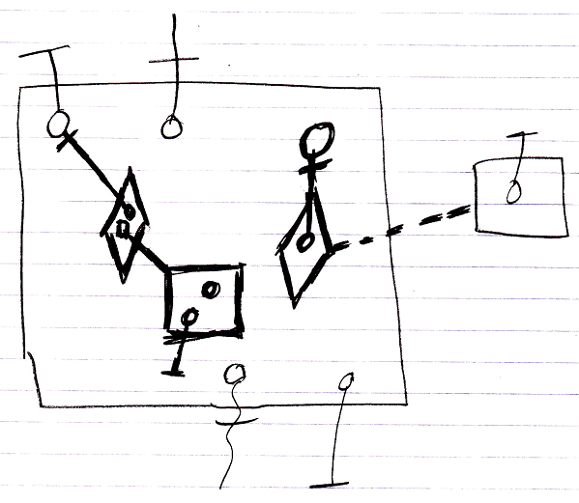

The contents of the large square, drawn with thick lines, are the command’s procedure, because they are all private contents The objects contained inside the large square, that are drawn with normal lines, are the command’s parameters.

